**Problem Statement**

**Product Dissection for top leading Platforms**

Welcome to this case study on dissecting and designing products for top leading platforms. In this case study, you will delve into the intriguing world of schema design for a prominent platform of your choice. Your task is to choose a top leading platform, research its features, and meticulously craft a schema design that encapsulates the essence of its functionality. By focusing on key entities, attributes, and relationships, you will gain invaluable insights into how data architecture drives the platform's effectiveness.

**Step 1: Choose a Leading Platform**

Select a leading platform of your choice, which could span various domains such as social media, e-commerce, finance, or any other industry. This choice will form the foundation of your exploration into its schema design.

**Step 2: Research:**

Thoroughly research the platform you have selected. Investigate its core features, functionalities, and user interactions. Identify the top features that define its user experience and contribute significantly to its popularity.

**Step 3: Product Dissection and Real World Problems solved by the platform**

In this step, you will meticulously analyse the platform's standout features and how they provide innovative solutions to real-world challenges. By identifying key functionalities that resonate with users, you'll unravel how the platform effectively addresses problems and enhances user experiences. This dissection will serve as the foundation for understanding how the schema design aligns with the platform's core objectives.

**Step 4: Case Study on the real world problems and approach to solving them**

In this pivotal step, you will expand on the real-world challenges uncovered in Step 3 through a comprehensive case study. Delve into specific instances where users encountered difficulties and showcase how the platform's unique features provided effective solutions. By dissecting the approach taken by the platform to overcome these challenges, you'll gain a deeper appreciation for the platform's user-centric design philosophy and how it shapes the schema design.

**Step 5: Schema Design Based on Top Features**

Based on the features you have identified, craft a schema design that reflects the platform's data structure. Focus on the key entities, attributes, and relationships that underpin the chosen features. Your schema should capture the essence of how the platform organises and utilises its data.

**Step 6: Rationale Behind the Design**

While creating the schema design, consider the rationale behind the platform's choices. Reflect on why certain entities and relationships were chosen and how they align with the platform's goals. This will help you understand the strategic decisions driving the schema's architecture.

**Step 7: Create an ER Diagram**

Utilise tools like the Miro platform or similar applications to create an illustrative Entity-Relationship (ER) diagram. This diagram should vividly depict the entities, attributes, and relationships present within your schema design. The ER diagram will serve as a visual representation of your insights.

**Step 8: Presentation of Findings**

Present your findings in a clear and concise manner. Showcase your understanding of how the schema design impacts the platform's functionality and user experience. Explain how your chosen features are integrated into the schema and how the schema's structure supports the platform's objectives.

**Task Details:**

1. **Answer Submission:** Your submission should include well-structured solutions for all provided questions related to product schema designs.
2. **Video Creation:** Create an informative and engaging video where you thoroughly explain the Case Study.
3. **Depth and Clarity:** Ensure your solutions are detailed and showcase your understanding of product schema design principles. Similarly, in the video, provide clear explanations that are easy to understand for a wide audience.
4. **Creativity Encouraged:** You are welcome to utilise visuals, diagrams, or creative elements to enhance the clarity and impact of your explanations.

**Note:**

1. Duplicate this document and proceed to write your solutions and prepare your video.
2. Include the video link in this document before final submission.

Best of luck in completing this project and showcasing your prowess in dissecting and designing product schema for leading platforms! **For reference, we have also conducted a case study on Instagram, which you can find below. This case study will provide you with valuable insights into how schema design plays a pivotal role in shaping the functionality and success of a prominent platform.**



**Product Dissection for Amazon**

### **Company Overview:**

Amazon is a multinational technology company that focuses on e-commerce, cloud computing, digital streaming, and artificial intelligence. It is considered one of the Big Five American technology companies, along with Alphabet, Apple, and Meta. Amazon is an e-commerce company that was founded in 1994 by Jeff Bezos. The company is the leading e-retailer in the United States, with over 300 million active customer accounts globally. Amazon provides products such as apparel, auto and industrial items, beauty and health products, electronics, grocery, games, jewellery, kids and baby products, music, sports goods, toys, and tools.

### **Product Dissection and Real-World Problems Solved by Amazon:**

Amazon, a global e-commerce and technology powerhouse, stands at the forefront of innovation in addressing real-world challenges through its multifaceted platform. Rooted in a customer-centric approach, Amazon's core features and functionalities span diverse areas, ensuring convenience, choice, and seamless experiences for its global user base.

At the heart of Amazon's e-commerce prowess is a feature-rich platform encompassing product listings, user reviews, and a sophisticated recommendation engine. This enables users to navigate a vast array of products, fostering a user-friendly and informed shopping experience. Complementing this, Amazon Web Services (AWS) revolutionises cloud computing, offering scalable and flexible solutions that cater to the diverse needs of businesses, reinforcing Amazon's technological leadership.

The introduction of Amazon Prime stands as a testament to the company's commitment to user satisfaction. With features like fast shipping, streaming services, and exclusive deals, Amazon Prime not only elevates the overall user experience but also fosters customer loyalty, thereby driving revenue growth.

The Amazon Marketplace, a platform allowing third-party sellers to reach a global audience, expands the product selection and competition on the platform. Through Seller Central and Fulfilment by Amazon (FBA), Amazon provides tools and services that streamline logistics, enhance product variety, and contribute to additional revenue streams.

Much like Instagram's focus on visual storytelling, Amazon's success lies in its ability to address real-world challenges through seamless features. One-Click Ordering simplifies the purchase process, Prime enhances customer satisfaction, AWS offers scalable solutions, and the Marketplace fosters a diverse and expansive online marketplace. Together, these features contribute to Amazon's global popularity and its role as an industry leader in e-commerce and technology.

### **Case Study: Real-World Problems and Amazon's Innovative Solutions**

Amazon's standout features directly address real-world challenges, demonstrating the platform's commitment to enhancing user experiences and providing solutions that cater to a diverse range of needs. Whether it's streamlining the purchasing process, ensuring swift and reliable shipping, assisting businesses in scaling operations, or connecting sellers with a global market, Amazon's features have a tangible impact on solving practical problems for both users and businesses.

#### Case 1: Timely Gift Delivery

Problem:

A user finds themselves in a situation where they need to send a last-minute gift to a friend but has limited time for the purchase and delivery process.

Solution:

Utilising One-Click Ordering, the user can make a swift and efficient purchase without going through a lengthy checkout process. This feature streamlines the ordering experience, reducing the time needed to complete the transaction. Furthermore, by leveraging Amazon Prime's fast shipping services, the user ensures timely delivery of the gift to the friend, meeting the need for a quick and reliable solution during time-sensitive situations.

Outcome:

The user successfully sends a timely gift to their friend, leveraging the convenience of One-Click Ordering and the expedited shipping benefits of Amazon Prime.

#### Case 2: Cloud-based Solutions for a Startup

Problem:

A startup is experiencing challenges in scaling its operations due to limitations in infrastructure and the need for a cost-effective solution.

Solution:

Facing scalability issues, the startup turns to Amazon Web Services (AWS) for cloud-based solutions. AWS provides scalable computing power, storage, and various other services that allow the startup to adapt its resources based on demand. This cost-effective cloud solution empowers the startup to scale its operations efficiently without the need for heavy infrastructure investments.

Outcome:

The startup successfully scales its operations, leveraging the flexibility and scalability of AWS, resulting in improved efficiency and reduced operational costs.

#### Case 3: Global Expansion for a Small Business

Problem:

A small business desires to expand its customer base globally but faces challenges in reaching an international audience.

Solution:

The small business opts to join the Amazon Marketplace, a platform that enables third-party sellers to list and sell their products globally. By leveraging Amazon's vast customer base and logistics infrastructure, the business can overcome the challenge of market reach and connect with customers worldwide. Amazon Marketplace serves as a gateway for the small business to access a diverse international audience.

Outcome:

The small business successfully expands its reach, reaching customers globally through the Amazon Marketplace, ultimately boosting sales and brand visibility.

Conclusion:

These case studies demonstrate how Amazon's features effectively address real-world problems, providing practical solutions for users, startups, and small businesses alike. Whether it's ensuring timely gift delivery, facilitating scalable cloud solutions for startups, or enabling global expansion for small businesses, Amazon's versatile features play a crucial role in solving diverse challenges across different scenarios.

### **Top Features of Amazon:**

Amazon, being a multifaceted platform, offers a variety of features across its diverse services. Here are some of the top features that contribute to Amazon's success:

* One-Click Ordering:
  + *Description:* Streamlined and quick purchasing process with a single click.
  + *Functionality:* Reduces steps for users, promoting impulse buying.
  + *User Experience Impact:* Enhances convenience and expedites the checkout process.
* Amazon Prime:
  + *Description:* Subscription service offering benefits like fast shipping, streaming services, and exclusive deals.
  + *Fast Shipping:* Free two-day or same-day delivery for eligible items.
  + *Streaming Services:* Prime Video and Prime Music provide a vast library of content.
  + *User Experience Impact:* Elevates the overall Amazon experience, fostering loyalty.
* Amazon Web Services (AWS):
  + *Description:* Comprehensive cloud computing platform.
  + *Scalability:* Allows businesses to scale resources based on demand.
  + *Flexibility:* Offers a wide array of services suitable for various industries.
  + *Reliability and Security:* Robust infrastructure and security features ensure high reliability.
* Amazon Marketplace:
  + *Description:* Platform enabling third-party sellers to list and sell products.
  + *Seller Central:* Portal for sellers to manage inventory and customer interactions.
  + *Fulfilment by Amazon (FBA):* Amazon handles storage, packing, and shipping for sellers.
  + *Global Reach:* Connects sellers with a vast global customer base.
* Virtual Assistant (Alexa):
  + *Description:* AI-powered virtual assistant integrated into devices like Echo and Fire TV.
  + *Voice Commands:* Users control smart devices, play music, and get updates using voice commands.
  + *Skills:* Third-party developers create skills to enhance Alexa's capabilities.
* Product Recommendations:
  + *Description:* AI-driven recommendation engine based on user preferences and browsing history.
  + *Functionality:* Enhances the shopping experience by suggesting relevant products.
  + *User Experience Impact:* Increases product discovery and customer engagement.
* User Reviews:
  + *Description:* Detailed customer reviews and ratings for products.
  + *Functionality:* Provides insights for potential buyers, aiding in informed decision-making.
  + *User Experience Impact:* Builds trust and transparency in the purchasing process.
* Amazon Fresh:
  + *Description:* Grocery delivery and pickup service.
  + *Functionality:* Delivers fresh produce and grocery items to customers' doorsteps.
  + *User Experience Impact:* Expands Amazon's services into the grocery industry, providing convenience.
* Amazon Studios:
  + *Description:* Amazon's original content production for movies and TV shows.
  + *Functionality:* Creates exclusive and diverse content for Prime Video subscribers.
  + *User Experience Impact:* Enhances the entertainment offerings for Prime members.

These features collectively contribute to Amazon's popularity by providing a comprehensive, customer-centric, and innovative platform across various industries.

### **Schema Description:**

**Schema Design Based on Top Features:**

Entities:

1. User:

Attributes:

- ID (Primary Key)

- Name

- Address

- Payment Information

2. Product:

Attributes:

- ID (Primary Key)

- Name

- Description

- Price

3. Order:

Attributes:

- ID (Primary Key)

- Products (List of Product IDs)

- Delivery Status

- Timestamp

4. Seller:

Attributes:

- ID (Primary Key)

- Name

- Products Offered (List of Product IDs)

5. AWS Service:

Attributes:

- ID (Primary Key)

- Type

- Usage Data

**Relationships:**

1. Users place Orders:

Description: A user can place multiple orders, and each order is associated with a specific user.

Connection: User (ID) connects to Order (ID)

2. Products are sold by Sellers:

Description: Each product is associated with a seller, indicating who sells the product.

Connection: Product (ID) connects to Seller (ID)

3. AWS Services are utilised by Businesses:

Description: Businesses utilise various AWS services for their operations, indicating a usage relationship.

Connection: AWS Service (ID) connects to Business (ID)

**Schema Overview:**

- The User entity represents individuals who interact with the platform, storing essential information such as their ID, name, address, and payment details.

- The Product entity captures details about the items available on the platform, including ID, name, description, and price.

- The Order entity tracks individual transactions, with information about the ordered products, delivery status, and timestamp.

- The Seller entity contains details about businesses selling products, including ID, name, and a list of products offered.

- The AWS Service entity represents various cloud services offered by Amazon Web Services, including ID, type, and usage data.

#### **Schema Design Rationale:**

- The schema design reflects the relationships between users, products, orders, sellers, and AWS services, encapsulating the core functionalities of Amazon.

- The use of primary keys ensures unique identification for each entity.

- Relationships depict how users interact with the system by placing orders, how products are associated with sellers, and how businesses use AWS services for their operations.

This schema design provides a foundational structure for understanding the data architecture underlying Amazon's top features, facilitating effective management of user information, product details, order processing, seller associations, and the utilisation of AWS services.

**Rationale Behind the Design:**

Entity and Relationship Selection:

1. User Entity:

Rationale: Users are central to the platform's functionality. Including essential user information allows for personalised services, such as order tracking and targeted recommendations.

2. Product Entity:

Rationale: Products represent the core offerings of Amazon. Including details such as name, description, and price enables effective catalogue management and a rich shopping experience.

3. Order Entity:

Rationale: Orders capture the transactional aspect, tracking what users purchase, their delivery status, and when transactions occur. This supports order fulfilment and provides insights into user behaviour.

4. Seller Entity:

Rationale: Sellers are essential as they represent businesses offering products on the platform. Linking sellers to products allows for a clear association, aiding inventory management and order fulfilment.

5. AWS Service Entity:

Rationale: Reflects the diversification of Amazon into cloud services. Linking AWS services to businesses aligns with Amazon's goal of providing comprehensive solutions, supporting businesses in their scalability endeavours.

Relationships:

1. Users place Orders:

Rationale: Captures the fundamental interaction between users and the platform, aligning with Amazon's user-centric approach. This relationship facilitates order history, personalised recommendations, and an efficient shopping experience.

2. Products are sold by Sellers:

Rationale: Establishes a direct association between products and sellers, enabling efficient management of inventory, product listings, and order fulfilment. Aligns with Amazon's commitment to providing a diverse marketplace.

3. AWS Services are utilised by Businesses:

Rationale: Reflects the expansion of Amazon into cloud services. This relationship aligns with Amazon's strategy of offering scalable solutions to businesses, fostering growth without heavy infrastructure investments.

**Alignment with Amazon's Goals:**

1. Seamless User Experience:

Alignment: The inclusion of User and Order entities, along with the Users place Orders relationship, supports Amazon's goal of providing a seamless user experience. Users can easily navigate, place orders, and track their transaction history.

2. Diversity in Product Offerings:

Alignment: The Products are sold by Sellers relationship ensures a diverse marketplace. This aligns with Amazon's goal of offering an extensive range of products to cater to diverse customer needs.

3. Scalability with AWS Services:

Alignment:The AWS Services utilised by Businesses relationship supports Amazon's commitment to providing scalable solutions. This aligns with the company's focus on empowering businesses to grow without facing scalability challenges.

**Conclusion:**

The schema design is strategically crafted to align with Amazon's overarching goals of delivering a seamless and scalable user experience. By emphasising user interactions, diverse product offerings, and scalable solutions through AWS services, the schema encapsulates the core functionalities that contribute to Amazon's success as a global e-commerce and technology leader. The chosen entities and relationships reflect the strategic decisions aimed at supporting Amazon's commitment to customer satisfaction, product diversity, and business scalability.

### **ER Diagram:**

an ER diagram that vividly portrays the relationships and attributes of the entities within the Amazon schema. This ER diagram will serve as a visual representation, shedding light on the pivotal components of Amazon's data model. By employing this diagram, you'll gain a clearer grasp of the intricate interactions and connections that define the platform's dynamics.

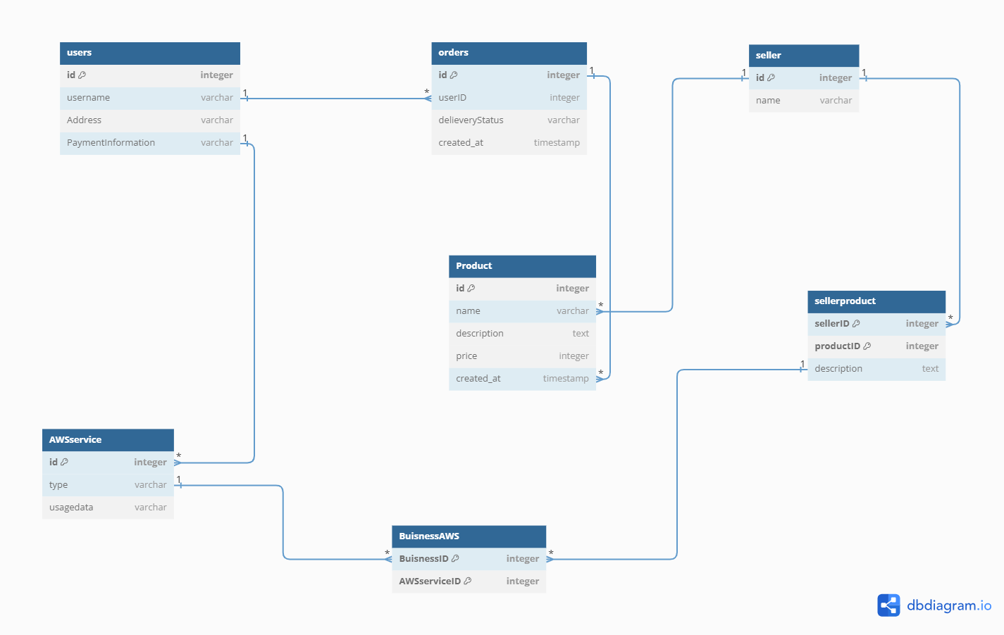

### 

### 

### **Conclusion**

**In conclusion, the dissection of Amazon's product features and schema design underscores its unrivalled success in addressing real-world challenges. From the streamlined One-Click Ordering to the multifaceted Amazon Prime and revolutionary AWS, each element contributes to a seamless user experience. The schema design, encompassing entities like User, Product, and AWS Service, strategically aligns with Amazon's commitment to scalability and user-centricity. Through innovative solutions like the Amazon Marketplace, the platform not only caters to diverse user needs but also empowers businesses globally. Amazon's product dissection reveals a holistic approach that defines the benchmark for e-commerce, technology, and customer satisfaction.**

**Github: www.github.com/RAHULNEGI1620/Product-Dissection**